**Smart Tennis Sensing Device for Game Play Analysis**

ECE4871 Senior Design Project

Team 1

Project Faculty Advisor, Dr. David Anderson

Lycia Tran, EE, [ltran65@gatech.edu](mailto:ltran65@gatech.edu)

Shez Malik, CompE, smalik46@gatech.edu

Rajan Vivek, EE, rvivek@gatech.edu

Robert Nelson, EE, [rnelson71@gatech.edu](mailto:rnelson71@gatech.edu)

Anubhav Agarwal, EE, aagarwal368@gatech.edu

Submitted

November 22, 2021**Table of Contents**

**Executive Summary** iii

1. **Introduction** 1
   1. Objective 1
   2. Motivation 1
   3. Background 2
2. **Project Description and Goals** 3
3. **Technical Specification** 6

3.1 Motion Capture Specifications 6

3.2 Microcontroller Specifications 7

3.3 Overall System Specifications 7

1. **Design Approach and Details** 8
   1. Design Approach Overview + Block Diagram 10
      1. Motion Detection and Physical Design 10
      2. Data Processing and Feature Extraction 12
      3. Learning Algorithms for Activity Recognition 12
      4. Microcontroller and Electronics Hardware 13
      5. Web applications and User Experience 14
   2. Preliminary Concept Selection and Justification 16
      1. Motion Detection and Physical Design 16
      2. Data Processing and Feature Extraction 17
      3. Learning Algorithms for Activity Recognition 17
      4. Microcontroller and Electronics Hardware 18
      5. Web applications and User Experience 20
   3. Engineering Analysis and Experiment 21
   4. Codes and Standards 22
   5. Constraints, Alternatives, and Tradeoffs 23
2. **Project Demonstration** 24

5.1 Shot Speed 25

5.2 Shot Type 25

5.3 Hit Location 25

1. **Schedule, Tasks, and Milestones** 26
2. **Marketing and Cost Analysis** 26
   1. Marketing Analysis 26
   2. Cost Analysis 28
3. **Current Status** 29
4. **Leadership Roles**  30
5. **References** 32

**Appendix A** 37

**Appendix B** 39

**Appendix C** 40

**Appendix D** 42

**Executive Summary**

Tennis is one of the most popular sports worldwide, and ample attention has been drawn towards how athletes can perfect their gameplay. With the proliferation of wearables and hearables, end consumers for such products have increasingly demanding requirements for domain-specificity, portability, and low-power consumption when capturing motion— specifically in tennis. Existing smart tennis sensors for recording gameplay are expensive, inaccurate, and tend to fall off the racket. Team 1 intends to develop a low-cost analytics system and sensing device that can be attached to any tennis racquet to record and visualize metrics about tennis gameplay in real-time for the athlete. The device will consist of a motion capture module, a microcontroller with low-energy Bluetooth capabilities, a lithium-ion power supply, a durable yet non-obtrusive casing to house the electronics and securely attach to any racket, and an accompanying web application to intuitively visualize the processed data to the user. A combination of machine learning and signal processing algorithms will be used to process the collected data into the desired performance metrics. This device will record, extract, and visualize performance metrics including swing speed, swing type, and location of contact between the ball and racket. Tennis players of all income and skill levels will be able to track their performance metrics and improve their game play. The expected outcome of the design is a fully functioning prototype that will cost approximately $49.

**Smart Tennis Sensor for Game Play Analysis**

1. Introduction

Team 1 will design a smart tennis sensing device that can be attached to a tennis racket and record performance metrics including swing speed, swing type, and location of contact between the ball and racket. The team will additionally design an accompanying web application to visualize the collected data in real-time. The team is requesting $49 to develop and test the prototype of the sensing device.

1.1 Objective

The team will design and prototype a sensor system that can be attached to a tennis racquet and record useful tennis performance metrics including trends in shot speed, shot type, and location of ball collision on the racquet. The motion capture module will collect the raw movement data from user gameplay. A microcontroller with low-energy Bluetooth capabilities will extract desired performance metrics from the raw data using signal processing algorithms and send these metrics to the accompanying web application for user consumption. A 3.7V lithium-ion power supply will be used to power the system. The sensor system will be encased in a durable, non-obtrusive casing and will securely attach to a tennis racquet.

1.2 Motivation

Tennis is a sport with a relatively high barrier to entry – it requires equipment, access to a court, and, most importantly, specialized coaching for teaching proper game mechanics. Coaching is very expensive, with an average cost of $75 per hour [1]**.** This can prevent many players from seriously pursuing the sport. Smart tennis sensors aim to level the playing field by giving players personalized feedback about their game. Current sensors on the market are not accurate enough to provide usable information, and as a result have largely been unsuccessful. A more thorough analysis of the competition can be found in section 7.1. The team intends to develop an effective and inexpensive product to provide accurate, useful, and timely data of relevant tennis metrics to further democratize the sport.

1.3 Background

Sports technology has become increasingly popular over the years and continues to grow in popularity. The global smart sports equipment market is estimated to be worth $12.0 billion by 2026. Smart sports equipment allows both athletes and coaches to track gameplay analytics as well as individual player performance metrics. This allows players and coaches to create training programs to target weaker areas of athlete performance, allowing for greater player improvement. Player performance metrics can also be used to track the safety of the athlete, thus lowering the risk of injury [2].

Fitness trackers have also gained popularity among non-athletes as well, consisting of 72% of wearables and hearables on the market today [3]. Fitbit is a popular fitness tracker with various products capable of tracking different health and performance metrics of the user such as heart rate, activity, and sleep [4]. Around 19% of Americans use a wearable fitness tracker and a mobile health app, making fitness tracking and performance analysis a popular and prevalent technology market [5].

Two key technologies have underpinned the growing trend of human physiologic function and performance in real-time activities: advances in sensor hardware and advances in machine learning. Hardware advances including the development of microelectromechanical systems (MEMS) have allowed a dramatic decrease in the size and cost of sensing technologies, making the placement of sensors directly on the human body and sports equipment feasible [37]. Concurrently, advances in machine learning have allowed unprecedented performance of automated activity recognition from raw sensor data, allowing greater insight extraction and domain specificity to be achieved by sensing devices. These technologies form the foundation of our proposed technical solution.

2. Project Description, Customer Requirements, and Goals

*Note: QFD is in Appendix D*

There are several groups of stakeholders for this project. First, there are the Senior Design students, otherwise known as the engineering team. These individuals have a high stake in ensuring the product succeeds, and in a commercial situation this pursuit would be their full time job. The team has a vested interest in satisfying the needs of all other stakeholders since they directly control the success of the product.. Next, the customers are also a very important group of stakeholders. Although the engineering team designs the product, the customers control the product features due to their demand dictating product success. Although the individual customer does not hold much power, the customers hold a lot of power as an aggregate due to their collective buying power. Next, the employees of the company are also important stakeholders. These employees do not control the features of the product or design goals, but their cooperation is critical to product success, and so it is prudent that the lead engineers (Senior Design students) consider their valuable technical input. It is key to avoid large turnover in this category so that an internal knowledge base is accumulated. Finally, there are investors in the company. As financial backers, investors hold significant power. Since product development may not be able to move forward without their support, their opinions are likely to have strong influence.

As discussed above, the customer is a critical stakeholder for ensuring the success of the product. Although the engineers and investors have the power to implement their decisions, the customers are ultimately the ones that make scaling the product to large markets possible. Thus, from an early point in the design process, it will be important to spend money on market research to figure out what is desired out of a smart racket by both professionals and novices in tennis. First, the customer likely needs to see data for the percentage of strokes taken of a certain type. Stroke type is a very important parameter, especially for beginners that are still learning different ways to hit the ball. Next, the customer will likely desire an aggregate metric on their serve speed across all serves for the current session. This will help them to track their power across multiple different practices and monitor their progress in strength development. Finally, the customer will likely desire a map of where the ball hit the racket to determine whether they hit the ball near the “sweet spot,” a measure of how optimal the hit was. Customers from the novice to expert benefit, as all skill levels in tennis still practice many of the same techniques. The final area needed for customer satisfaction is seamless integration with gameplay. In order to ensure the device is usable, the form factor must be small enough so that the user can forget the device is there. In order to make the device appeal to large markets, keeping a cost of under $100 at the final scale will be reasonable to compete with existing products.

First, in regards to sensing, the smart tennis sensor needs to be able to sense swings of all different kinds by both strong and weak players. In the strongest cases, tennis serves can reach up to 200 G, which means that the accelerometer must be able to sense movement of this magnitude. Reported metrics should be accurate enough to ensure that they are useful to the athlete. (See Table 3 for performance specifications). Next, the sensor must stay active throughout a practice or gameplay session. This means that performance of the battery is also a critical factor. For convenience, the battery should last at least 6 hours. A 155mAh Lithium-ion battery is an ideal choice due to easy recharging and long life. The next critical area of engineering performance is the signal processing and algorithm performance. In real life, coaches will want almost instant feedback on the types of shots taken by their players, which means the latency from swing to the appearance of the data on the web app must be very low, on the order of seconds. A safe boundary of 200 ms is reasonable. Although this metric is important, it is not as critical as algorithm accuracy, and it is acceptable if the latency is within the 200ms boundary 90% of the time. Additionally, in order to facilitate acceptable data for the shot type and speed classifier, feature extraction must be robust enough to identify areas of interest.

The primary constraint of the smart tennis racket is the size and placement of the device. In the game of tennis, the racket usually does not have any attachments, a key point that means the form, factor, and weight of the device will have to be small enough to stay unnoticed by the player. In order to make sure this constraint is satisfied, the best strategy will be to make several sample form factors with various shapes and weights to be tested by skilled tennis players. The next constraint, low power consumption of the electronics, is a direct consequence of the previous constraint. In order to fit in the small form factor, the battery of the smart racket must be extremely small. This means that all electronics, especially the communications module, will have to be designed with ultra-low power consumption in mind. By using Bluetooth Low Energy, power saving can be achieved in the communications module. Additionally, low power sensors will also need to be selected since the sensor will almost always be on during gameplay.

The Smart Tennis Racquet must meet the codes and standards from two primary categories of governing bodies: official electronics standards for consumer devices and official tennis rules. The first regulation of concern comes from the International Tennis Federation Appendix II [12]. In the case of the Smart Tennis Racket, Rule D of this section discusses that attachments which change the moment of inertia or any performance properties of the racket are not allowed. The International Tennis Federation permits the use of player analysis technology during official tennis gameplay, but requires that such technology satisfies the official rules of coaching. Because this information is similar to what a coach may communicate to the player, it is important that this information is not available to the player at moments when coaching is not permitted. According to Rule 30, a coach may communicate with players during a set break or when players change ends at the end of a game, but not during a tie-break game or at any other points in time. The primary mode of communication between the racquet and player is through a web application, so these requirements will be satisfied assuming the player does not have their smartphone during the match.

3. Technical Specifications

3.1 Motion Capture Specifications

**Table 1. Motion Capture Specifications**

| **Item** | **Specification** |
| --- | --- |
| Dual tri-axial accelerometers | ± 16g for small accelerations  ± 200g for large accelerations |
| Tri-axial gyroscope | ± 2000°/s |
| Tri-axial magnetometer | ± 8 Gauss |
| Tri-axial barometer | 200-1100 hPa |
| Temperature sensor | ± 0.5 K |
| Sampling rate | 120-200 Hz |
| Power supply | 1.71-3.6 V |
| Accuracy | 1024-2048 LSB/g |

3.2 Microcontroller Specifications

**Table 2. Microcontroller Specifications**

| **Item** | **Specification** |
| --- | --- |
| Standard library version | C++11 or newer |
| Platform precision | 32 bit |
| Communications protocols | Bluetooth LE, I2C, SPI |
| CPU Flash Memory | min. 16 KB |

3.3 Overall System Specification

**Table 3. Overall System Specifications**

| **Item** | **Specification** |
| --- | --- |
| Weight | < 0.7 oz |
| Size | 35x25x8 mm |
| Casing | durable and flexible material, Epoxy |
| Battery | 155 mAh lithium-ion battery |
| Latency | 150-400ms |
| Shot Classification Model Performance (F1-Score) | ≥ 90% |
| Shot Speed Prediction Error (Root Mean Square Error) | 5 mph |
| Ball Collision Location Prediction Error (Root Mean Square Error) | 5 inches |

4. Design Approach and Details

*System Overview*

The prototype will be a device that the user can attach to the bottom of their tennis racket. It will consist of a motion capture module, a microcontroller, an algorithm to filter and identify the raw data, and a web application to display the computed data. The motion capture hardware will involve dual tri-axial accelerometers, one with a sensitivity of ±16g and the other with a sensitivity of ±200g. This will ensure the device will be capable of capturing low-impact accelerations from moderate swings and high-impact accelerations from serves. The motion capture module will also contain a gyroscope with a sensitivity of ±2000°/s to capture angular momentum and velocity as well as a tri-axial barometer, magnetometer and temperature sensor to accommodate for external stimuli impacting the gyroscopic sensor. The data will then be processed through a trained machine learning model running on the microcontroller to effectively post-process the data with an accuracy within our specifications. The data will then be communicated from the microcontroller to the web application via Bluetooth Low Energy to ensure power consumption remains minimized. The data will then be intuitively displayed for the user to analyze their gameplay within the application. The system will be powered by a 3.7V lithium-ion battery to create a robust, lightweight and physically non-obtrusive solution to real tennis gameplay analytics. A block diagram of the overall system is shown below in Figure 1 and Figure 2 shows the physical design of the device when attached to the tennis racket.

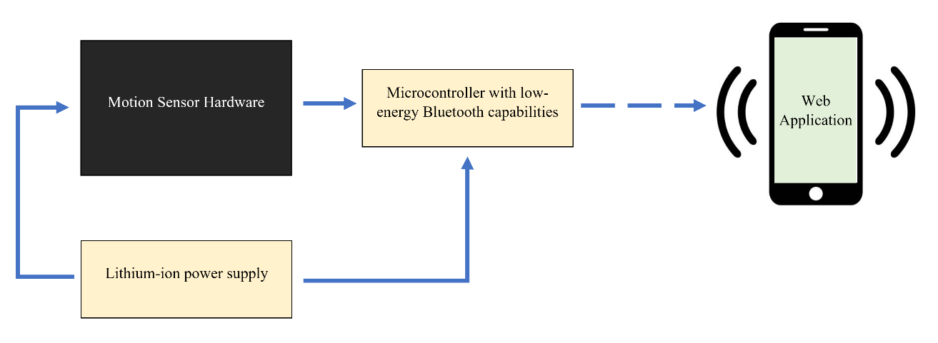

Figure 1. Block diagram of overall system. The Motion Sensor Hardware block includes the accelerometers, gyroscope, magnetometer, temperature sensor and barometer used to capture the raw user data.

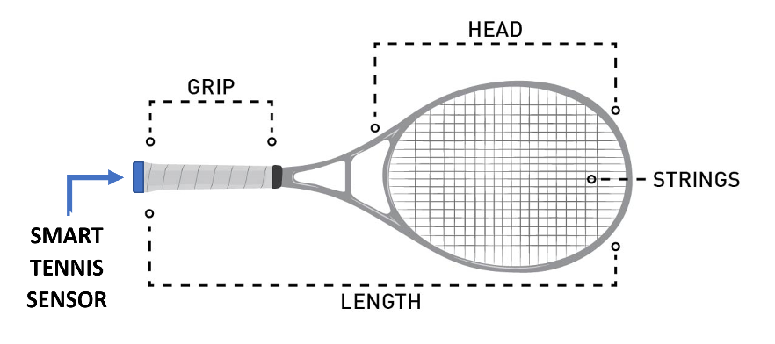

Figure 2. Final form of the prototype when attached to a tennis racquet.

4.1. Design Concept Ideation, Constraints, Alternatives, and Tradeoffs

The final device will need to fulfill the following functions: collect racquet movement data using accurate hardware with minimal size and cost, perform on-device data cleaning and feature extraction, measure metrics of interest using machine learning algorithms, wirelessly communicate this information to an external device, and visualize the information in an intuitive manner via the web application. The functions can be described respectively by the following categories: Hardware and Motion Detection, Data Processing and Feature Extraction, Learning Algorithms for Activity Recognition, Wireless Communication, and Web Application User Experience.

*Motion Detection and Physical Design (4.1.1)*

The motion detection aspect of the design will need to retrieve high-impact accelerations (for tennis serve speeds), low-impact accelerations (for common swing speeds and hit location), and angular momentum and angular velocity (for shot type, shot speed, and hit location). It is also necessary to ensure the devices are capable of sampling data points quickly enough to ensure a robust motion capture module that will not miss vital data points during a match or practice. Possible approaches to retrieving the desired data points would include motion capture modules embedded in the selected microcontroller or external sensor peripherals that communicate with the processing unit via serial peripheral interface (SPI) or inter-integrated circuit (I2C). Another important consideration resides within gyroscopic motion capture for angular momentum and angular velocity specifically. While gyroscopes are the most common approach for rotational data retrieval, these measurements can be significantly impacted by the relative magnetic field, air pressure and temperature [24]. Therefore, to ensure sufficient accuracy during the post processing of the rotational data captured, it would be worthwhile to attempt to recalibrate the gyroscopic data with modules to detect the aforementioned stimuli.

Moreover, the design will need to be lightweight, physically unintrusive, and durable. Ensuring the design’s weight and size remain as low impact as possible will satisfy the need of a lightweight and physically unintrusive analysis tool that amateurs and professionals can trust will not negatively impact their gameplay. As the device’s intended use is during physical activity, the physical design must be as durable as possible to ensure the device does not break if it is dropped outdoors, gets hit by a tennis ball, or during any other event that may incur damage during the rugged physical environment created by a tennis match. It’s noteworthy to mention that there is an inverse correlation between weight and durability. A heavier model may be more durable but it could negatively influence the user’s experience; therefore, a balance must be found when prototyping the device. Tradeoffs and design decisions will be further addressed in sections 4.2 and 4.5.

*Data Processing and Feature Extraction (4.1.2)*

Signal processing algorithms will be implemented in C code and uploaded to the microcontroller for onboard data cleaning, segmentation, and feature extraction. Possible techniques for cleaning include filtering in the frequency domain to remove high-frequency noise and thresholding in the time domain to determine when activity of interest is occurring. Secondly, possible segmentation techniques include a sliding window of fixed size and a dynamic windowing algorithm for recognition of diverse activity instances. Thirdly, possible feature extraction techniques include a variety of signal operations such as the mean, standard deviation, and the derivative operators in the time domain as well as the Fourier Transform, spectral energy, and Dual-Tree Complex Wavelet Transform. These operations afford the generation of expressive features that can be operated on by the learning algorithms for activity recognition. Selecting between these algorithms involves a trade-off between the performance and ease of implementing and debugging, which is discussed further in Section 4.2 and 4.5.

*Learning Algorithms for Activity Recognition (4.1.3)*

The output of the signal processing and feature extraction algorithms will be fed into a machine learning model to accurately detect common tennis metrics. Two model types can be used – classification and regression models. To classify shot type, a deep neural network (DNN) can be utilized. DNNs have been proven to effectively classify tennis shot types when using data from a motion capture module attached to the player’s wrist [25]. This same methodology can be easily extrapolated for use in a device that attaches to the racquet. There are different kinds of DNNs that can be leveraged for continuous motion detection – convolutional based neural networks [38], long-short-term memory models (LSTMs) [26], and residual networks. To estimate swing and serve speed, a regression model can be used based on the data from the motion capture hardware [27]. Regardless of model type, an effective model must be robust to different player types, and must be able to clearly detect when the racquet is being swung versus when the player is idle. Another key constraint that must be considered when working with DNNs is their time and space complexity. Traditionally, neural networks involve the tuning of thousands of parameters. Storing this can require a significant amount of RAM that not all microcontrollers have. The team intends to use frameworks like Tensorflow Lite to shrink and quantize the models to fit the constraints of an edge device. The constraint that limits time complexity of the model is inference latency. If the product aims to analyze real time data, the model should be able to run end-to-end inference in the order of 200-400 milliseconds. Making sure the model can run in a real game environment will require making sure our network is not too deep and doesn’t involve many expensive computations.

*Microcontroller and Electronics Hardware (4.1.4)*

When choosing a microcontroller, there are many important factors to consider. Ease of access to development kits is on the top of the list for prototyping code and verifying that the microcontroller will work for the desired application. Two companies in particular stand out for their development kits and seamless integration IDEs: STMicrolectronics and Texas Instruments. Both the TI Code Composer Studio and STM32 Cube IDE work under the surface to abstract the makefile level and flashing procedure one level up from the user, and although moving to using makefiles without the IDE may be necessary for accuracy increases due to performance bugs in the IDE, having a well-supported free IDE is critical in the early stages of development. On the hardware side, peripheral interfaces such as SPI, I2C, JTAG, and UART are essential since they are used to interface with sensors and modules on the PCB as well as debug the code. One of STMicroelectronics top offerings, the STM32H743ZI [21], satisfies all of these peripheral requirements which will allow it to communicate with all standard sensors via I2C and SPI and also be debugged with GDB via a cost effective JTAG such as the Segger J-Link [22]. I2C works via a two-wire communication protocol that contains a clock line and a data line for memory mapped IO access on sensors. Its simplicity makes it ideal for our application. Additionally, when collecting a rapid amount of data with sensors such as Inertial Motion Units (IMUs), Direct Memory Access (DMA) is an important parameter as it is necessary to not occupy CPU time with writing data from peripheral interfaces to the memory. Finally, an important additional constraint is power requirements, especially in a sports context where battery size is limited to avoid disrupting an athlete’s shot execution. In a study by Li et al. [23], an examination of power requirement evaluation using the TI CC2640R2 investigates ways to reduce power consumption in edge devices. Li et al. concluded that sampling rate and payload size both had limited effect on the power consumption, whereas transmission via Bluetooth modules had the largest drain on power. This means that a carefully executed strategy for data transmission to the user will be the most important factor rather than specific microcontroller parameters.

*Web Application User Experience (4.1.5)*

In order to allow users of the device to quickly and conveniently access their data, an intuitive web application will be developed. This interface will allow each user to log in and view the captured metrics of their gameplay in real time. The information should be visualized in a variety of graphs to make the information more digestible and draw attention to insights that are important to gameplay, such as trends in types of shots used and location of ball collision on the racquet. A trade-off exists between the granularity of data presented and the ease of consuming such data for end users. Additionally a major constraint to consider is the latency of data between the racket interaction and the information displayed on the webpage. Although this is not a problem when playing, it could become a problem for coaches who are looking for instant monitoring capability. Finally, one important societal factor to consider is the current graphic design standard in apps and web pages. An unattractive or antiquated interface is likely to reduce consumer preference of the device, regardless of its performance. In order to satisfy these expectations, it will be important to inspect current apps for popular UI design elements. A cultural factor to consider is that the popularity of athletic products is largely driven by their association with professional athletes and sports organizations. Thus, we should consider partnering with such individuals or groups for marketing.

4.2 Preliminary Concept Selection and Justification

*Motion Detection and Physical Design (4.2.1)*

Regardless of the design approach chosen for motion capture (onboard motion capture units on the microcontroller or external peripherals), motion capture for low impact accelerations in tennis will need to be captured with an accelerometer that supports a sensitivity of ± 16g to ensure sufficient accuracy. Likewise, high impact accelerations will only be captured by an accelerometer that supports a sensitivity of ± 200g [8,24]. Furthermore, the angular momentum and velocity will need to be captured via a tri-axial gyroscope that supports a sensitivity of ± 2000°/s [16, 24]. As mentioned in section 4.1.1, gyroscopes can be sensitive to external stimuli. To accommodate for this, the design will need to include a magnetometer with a sensitivity of ± 8 Gauss, a tri-axial barometer that supports a sensitivity range of 200-1100hPa in each direction, and a temperature sensor that supports a sensitivity of ±0.5 K[8][24]. Once the microcontroller is chosen, the remaining peripherals will be chosen to accommodate those which do not already exist onboard. Lastly, it has been proven by several studies that the ideal sampling rate for swinging based sports like tennis is around 128 Hz [8, 14, 24]. Therefore, all of the modules will need to support a sampling rate range of roughly 120-200 Hz.

A plausible approach for the physical design will be to ensure it satisfies the Adidas miCoach SPEED_CELL specifications of 35x25x8 mm to ensure that the device can easily be integrated into clothes, shoes, and equipment via the SPEED_CELL cavities [9]. This will allow for the design to have as low impact as possible on the end user as the SPEED_CELL infrastructure is already in place. As for weight and durability, the final prototype will be enclosed in an epoxy solution to protect the electronics during physical activity by providing impact absorption and external casing without adding excessive weight to the system.

*Data Processing and Feature Extraction (4.2.2)*

In consideration of the trade-off between algorithm complexity and the expressive capability of the extracted features, we will first select conventional algorithms that are straightforward to implement and move on to more complex and niche algorithms as needed. Specifically, we will use threshold analysis to identify regions of interest, a sliding window approach with fixed window size for segmentation, and a running average operation and Fast Fourier transform operation for feature extraction. These techniques have demonstrated success in similar applications [19,20]. The accuracy of the learning algorithms that operate on these features to identify desired tennis metrics will be determined. If the accuracies are below our desired specifications (See Table 3), we will evaluate more complex processing techniques including a dynamic windowing algorithm, wavelet filtering, and the Dual-Tree Complex Wavelet Transform.

*Learning Algorithms for Activity Recognition (4.2.3)*

The team is proposing to use a neural network for activity recognition over other machine learning methods for two main reasons - their ability to model non-linear data and their proven accuracy on tasks involving unstructured data such as motion sensor outputs. Despite their advantages, neural networks come with a major flaw - their requirement of vast amounts of training data. A large amount of recorded data is required to train the network (~10-20 minutes of recordings for each shot type). This will be a time-extensive part of the project and will require multiple people to swing the racquet for our model to be robust to different playing styles. Failure to collect high quality training data will result in poor model accuracy and will render the choice of network ineffective. After successfully recording enough diverse training data, the next challenge will be deploying this model to a resource constrained device. In the initial design, the team plans to use a standard convolutional neural network with a 4-5 way classifier for the different shot types. The team will first experiment with different depths of networks until a model is able to reach a reasonable accuracy threshold. Afterwards the model must be compressed and pruned in order to fit the memory requirements of the selected hardware. Once memory and accuracy criterias have been met, the team can measure end-to-end latency of the model and assess if it works in a real-game scenario. If the team comes to the realization that a neural network-based solution might not be practical, the team could explore more traditional learning models that rely more heavily on feature extraction and signal processing techniques.

*Microcontroller and Electronics Hardware (4.2.4)*

In order to evaluate which of the promising hardware options can be used, it is important to consider the feasibility with respect to the design specifications. First, in terms of selecting the peripheral hardware such as the IMU or extra accelerometers, the specifications discussed in the section above on motion detection will be used. In combination with these specifications, the costs of many breakout boards, surface mount ICs, and standalone modules can be considered. For example, Sparkfun [32] stocks a low cost breakout board for an IMU that will satisfy the low speed specification. The critical path for this will be the time it takes to analyze the data retrieved off of the sensor. Next, for the battery, a Lithium-Polymer design will be used to ensure high energy density and long lasting life. Although there are different battery technologies available, the primary focus of the first prototype stage is cost and the power requirements of the selected microcontroller development board. Since the computation requirements and ability to interface with the chosen sensors is a paramount priority, the battery will be chosen so that the microcontroller can be powered to the board’s specified power requirement. As a contingency plan for testing if the Li-Po battery fails, any standard USB power bank can be used to power most microcontrollers. One unknown aspect is the kind of connectors used on common batteries, and this is a next step that must be investigated. Next, in order to choose the microcontroller, all of the requirements in the section 4.1 microcontroller description will be considered. As investigated in that section, most development boards today have necessary features such as SPI, I2C, and Direct Memory Access (DMA). One additional important factor to consider is whether or not the microcontroller supports the Bluetooth Low Energy Protocol. This communications standard is a proven way to reduce power consumption during communications with the external interface (such as a smartphone), and it can be seen that one class of boards already considered, the STM32 Nucleo Development Kits, has support for this protocol via an add-on module [33]. Finally, the last requirement for considering a microcontroller is compatibility with TensorFlow Lite, one of the most common embedded machine learning frameworks. Most microcontrollers in the market are compatible with TensorFlow Lite, as it can be seen in the TensorFlow documentation [34] that the only requirement is using a modern software standard such as C++ 11. After all these considerations, it seems that selecting a board from the STM32 Nucleo line would be a good course of action due to the presence of all the necessary hardware factors, an IDE in the STM32Cube Development Environment, and presence of an external Bluetooth Low Energy add-on. In the event that this development board proves hard to work with, more beginner friendly options such as Arduino based products can be used.

*Web Application User Experience (4.2.5)*

*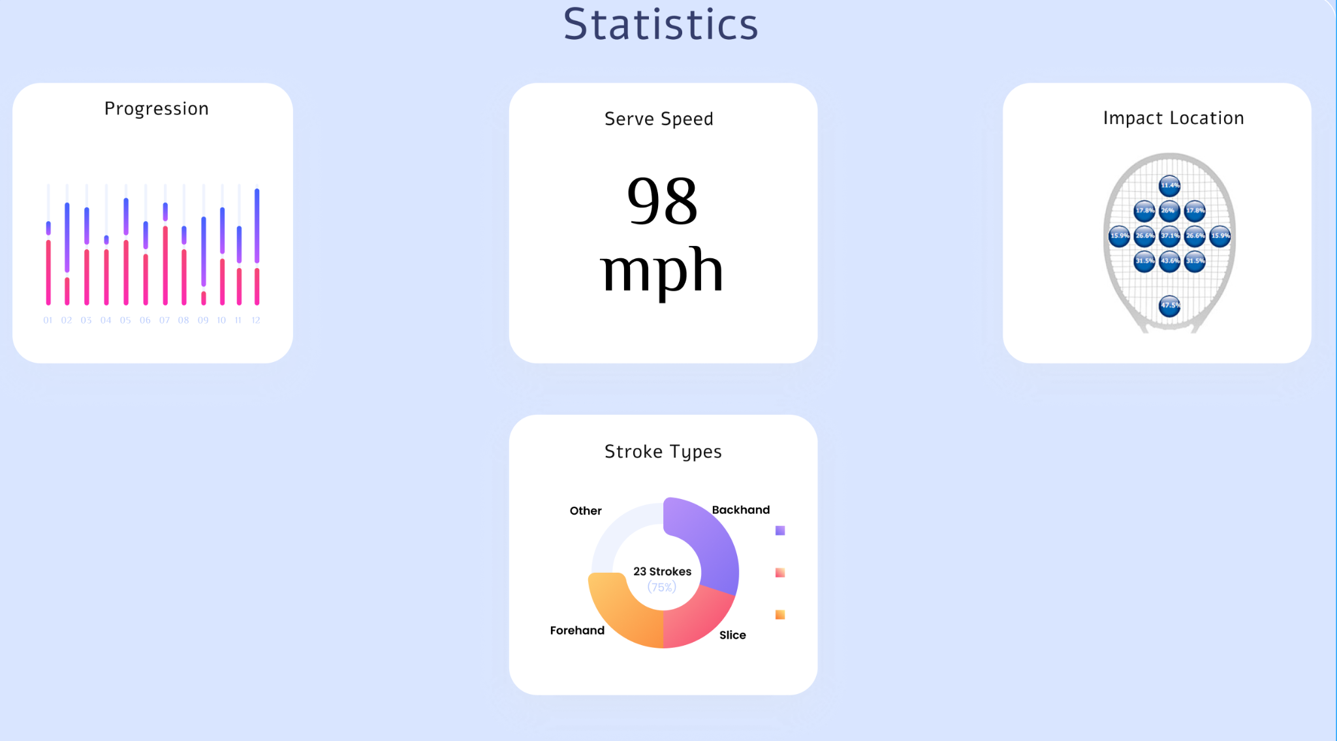Figure 3. Mock-up of Tennis Metric Visualization Web Application.*

In Figure 3, a mock-up of the Smart Tennis Sensing Device web app can be seen. There are several key elements of this window. First, in the top left corner, the user can see a visual bar graph that helps track the steps to achieving specific goals such as high percentage of perfect execution on a shot type. Next, the top middle box gives an aggregate average for the serve speed over all the serves in the current session of the web app. Next, in the impact location tab, the app will place a marker every time a ball hit is registered on the racket. This will help the user to visualise whether or not they can make improvements to shot power by changing the location of impact on the racket. Finally, on the bottom, there will be a pi-chart shot type comparison tool. This will be helpful to users that are looking to improve their game by practicing one type of shot more than the other. By visualizing the percentage of shots, they will be able to see that they are not mis-calculating how much they are using one stroke type and make sure that their technique for a shot type is correct. As a contingency plan, if it is found that this information is not helpful to users via market reviews and player interviews, data can be aggregated and displayed in different ways, such as number of hits and misses.

4.3 Engineering Analyses and Experiment

Prototype testing will be accomplished by evaluating our device’s reported metrics against ground truth, which will be collected during the experiments. Ground truth collection techniques will vary for each metric. These include a radar gun for determining shot speed, paint and a high-speed camera for determining location of ball collision on the racquet, and reports from the athlete for true classification of types of shots made. These are discussed in more detail in Section 5. To evaluate the performance of our algorithms, the root mean square error will be calculated for shot speed prediction and location of ball collision on the racquet, while the F1-score metric will be calculated for each shot type. These two metrics are conventional for regression and classification problems respectively.

Multiple rounds of experiments will be performed to collect approximately 30 samples of each swing type, 30 samples of serves for shot speed, and 30 samples of hits with the location of ball collision on the racquet recorded. These experiments will use a preliminary prototype involving 3D printed casing, allowing us to qualitatively evaluate the maneuverability of the racquet with the device as well as the effectiveness of the attachment device.

Next, 70% of this data (21 of 30 samples from each category) will be used to train our algorithms and 30% will be used to evaluate the algorithms. The algorithms will not be exposed to the test data prior to evaluation, allowing us to obtain an accurate measure of how effective our device is at generalizing to new gameplay. We will continue to refine our algorithms until our desired performance specifications are met. Based on our qualitative findings about racquet maneuverability and device attachment, the sensor casing and attachment component will be refined and then molded in epoxy for our finalized prototype.

4.4 Codes and Standards

Our device must meet the codes and standards from two primary categories of governing bodies: official electronics standards for consumer devices and official tennis rules. The first regulation of concern comes from the International Tennis Federation Appendix II, The Racket [12]. In this section, the Federation details racket construction procedures, allowed racket dimensions, and objects attached to the racket. In the case of the Smart Tennis Racket, Rule D of this section discusses that attachments which change the moment of inertia or any performance properties of the racket are not allowed. During the design process, negligible size and weight with respect to the racket will be a critical factor, and it will be prudent to attach different weights to the end of the racket before the product design is finished to test the range of weights that are negligible for game play. Since one of the main marketing factors of our device is seamless integration with gameplay, recruiting various players to test different weights and provide feedback will be important.

The International Tennis Federation permits the use of player analysis technology during official tennis gameplay, but requires that such technology satisfies the official rules of coaching. A player analysis device is defined as any device that performs recording, storing, transmission, analysis, or communication to the player of any means. Because this information is similar to what a coach may communicate to the player, it is important that this information is not available to the player at moments when coaching is not permitted. According to Rule 30, a coach may communicate with players during a set break or when players change ends at the end of a game, but not during a tie-break game or at any other points in time. If our device is to be used during official tennis gameplay, it must satisfy these requirements. This means that any features on the racquet itself that display information, such as LEDs or a screen (if we choose to use such devices) should be disabled during gameplay. We intend that the primary mode of communication between the racquet and player be through a web application, so simply not allowing the player to access a phone or computer during times when coaching is not allowed will satisfy these requirements.

In the case that we decide to turn this product into a wearable device like a wristband, IEEE presents some standards about wearable consumer electronics: “The application software should not read, write, modify, export or delete end user data without permission. In addition, it should monitor and verify that the application software present in wearable devices does not endanger network security” [2]. Even though this standard applies to wearable devices, we believe this would be an important standard to abide by even if our product is mounted on the racquet. We intend to satisfy this standard by not automatically manipulating user data, always notifying the user when recording data, and if we incorporate any kind of cloud technology, working with licensed cloud providers to store and manage data.

4.5 Constraints, Alternatives, and Tradeoffs

A significant trade-off to be considered is power consumption vs. accuracy. Reviewing the literature indicates that most IMUs/absolute orientation sensors are not accurate enough to sense rapid accelerations caused while playing tennis [24]. While the orientation sensor is valuable to detect less rapid accelerations for typical strokes (forehand, backhand, various spins) in the ±16g range, it is necessary to have an additional accelerometer specifically in the ±200g range for rapid accelerations caused by serves. Though the additional hardware will demand excess power, the tradeoff is necessary to maintain an accurate system.

Technical trade-offs regarding the choice of specific signal processing algorithms involve the ease of implementing and debugging these algorithms. For example, while it is likely that a dynamic windowing algorithm would result in more effective feature extraction, debugging such a feature is likely to be more difficult and time-consuming than debugging a conventional sliding window algorithm. In choosing between signal processing algorithms, we intend to take the approach of evaluating the performance of more simple techniques and increasing the complexity of our processing system as needed until the desired accuracy is obtained, as discussed in Section 4.3.

Another trade-off to be considered is cost versus size. Smaller and more accurate sensors and communications modules will be more expensive [10]. These metrics are important to ensure the device has as low an impact as possible on the player’s game in terms of physical presence.

Lastly, the design requires a low power system for computational intensive machine learning applications. Hardware-software trade-offs will revolve around low-compute versus accurate computing while also maintaining a low impact design in terms of power consumption and size.

5. Project Demonstration

The demonstration of the prototype will take place at the outdoor tennis courts at the Georgia Tech Peter’s Parking Deck. The system will be installed on a tennis racket and will export the data to the web app in real-time. Different techniques will be used to validate the data and will be dependent on the feature being extracted as described in subsequent sections below. Regardless of the technique demonstrated, each will uniquely prove the device’s capacity to accurately retrieve data, effectively post-process the information, communicate wirelessly, and intuitively display the information.

5.1 Shot Speed

For shot speed data validation, a user will hit a tennis ball with a racket that has the analysis device attached to the hilt. The data will be captured by the motion detection hardware, post-processed in real-time by the machine learning (ML) algorithm on the microcontroller, and exported to be displayed on the web application. When the ball is hit, the ground truth speed will be measured with an instant-read radar similar to how pitch speed is measured in baseball.

5.2 Shot Type

For shot type data validation, player volunteers will hit the tennis ball through an array of strokes: backhand, forehand, topspin, backspin, sidespin. The strokes will then be detected via the motion capture technology, translated by the ML algorithm, and communicated to the web application. The ground truth will be determined by the shot type that the volunteers believe they are using and verified by an experienced tennis athlete who witnessed the shot.

5.3 Hit Location

Lastly, for hit location verification, two approaches will be used for data validation. The first approach will require the tennis balls to be soaked in washable paint. The balls will then be served to a user with the device attached to the racket. The data will be captured and post-processed by the ML algorithm and then be communicated to the web application for display. This data can then be compared to exactly where the paint leaves a mark on the racket. The second approach will leverage high-resolution, slow-motion cameras available on the iPhone 11 and newer. The phone will be mounted on a tripod to record the ball hitting the tennis player’s racket while the device simultaneously analyzes the data retrieved from the swing. The hit location can then be compared between the recorded slow-motion video and the location shown within the web application.

6. Schedule, Tasks, and Milestones

Team 1 will be designing and testing this prototype over the next five months. Appendix A contains the Gantt chart of all major tasks to be completed. Each person will contribute and assist in the completion of each major task, however, depending on the category and specialization of the task, the task will be led and supervised by the respective coordinators (as designated in 9. Leadership roles). Appendix B contains the PERT Analysis Chart with the expected, pessimistic, and optimistic time estimates for each task.

7. Marketing and Cost Analysis

7.1 Marketing Analysis

With 87 million tennis players around the world, tennis is widely accepted as one of the most popular sports in the world. Any product that can be marketed to such a large and actively growing player base has huge potential for commercial success. The ideal consumer for a sensor device would be an intermediate tennis player that would benefit from a more nuanced improvement to their style of play.

Many products have been launched by different companies but none satisfy all of the team’s design criterias and none have been met with significant commercial success. In the middle of the bracket is the Koospur by Coollang, a Chinese hardware and IoT company that produces smart sport sensors. The Koospur costs $55 and attaches to the bottom of any racquet and connects to smartphones via Bluetooth 4.0. It claims to accurately collect metrics such as swing speed, strength and angle, and has a 6-hour battery life. Upon closer inspection we see that not only is it missing key metrics such as swing type and contact location, but it’s not even accurate with the data it does collect. 52% of the Amazon user reviews are 1-star, and users complained that it failed to log the vast majority of their swings.

Another device, this time at the higher end of the spectrum, is the Zepp Tennis Analyzer. The Zepp device was designed to track all the previously mentioned stats and even some more stats such as ball spin and sweet spot detection. It offers similar battery life to the Koospur (~5.5 hours) [39] but comes in at a price point of $220. Common customer complaints include the sensor flying off the racquet, and once again, the device failing to log most user strokes.

Sony also attempted to break into this market with it’s own smart sensor. Sony’s device had the most features, as well as the easiest to use IOS and Android apps, however it was plagued by poor sensor quality, and a terribly low battery life of two to three hours. The product has since been discontinued, however it still serves to demonstrate the importance of a device meeting all the key requirements – data quality, battery life, ease of use, price point and overall product quality.

Despite the various number of tennis sensors on the market, it seems that existing smart tennis sensors have not been particularly popular or widely-used in the tennis community. This is likely due to poor performance and execution rather than a lack of potential. For example, one article examined the accuracy of the BABOLAT and HEAD tennis sensor readings and found that there was a high error percentage (>10%) for the number of forehand and volley strokes in match settings [3]. This article’s findings are consistent with the review from many customers complaining about the inaccurate swing analysis, specifically with serves and volleys, poor user interface, short battery life, and inadequate mounting [2].

7.2 Cost Analysis

Please see Appendix C for the detailed breakdown of our cost analysis.

| Component | Estimated Cost | Reference |
| --- | --- | --- |
| Microcontroller with ± 16 G accelerometer | $20.00 | [15] |
| 3D Printed Packaging | $0.50 | [16] |
| Lithium Ion battery and Charger | $13.00 | [17] |
| Epoxy Casing | $0.50 | [18] |
| ± 200 G absolute orientation sensor with gyroscope, magnetometer, barometer and temperature sensor | $15.00 | [11] |
| **Total** | $49.00 | N/A |

Table 4. Estimated Prototype Cost.

Table 4 shows our estimated prototype cost calculated from approximate prices of all components of our prototype. Note that the tennis racquet is not included, as our device is intended to be a versatile module that can attach to any racquet. This estimated cost is well below the selling price of similar products, which range from $200 to as high as $6000 [29].

Table C.1 in Appendix C shows the cost analysis of our engineering team’s labor. Assuming that we are paid a typical engineer’s starting salary of $33.65/hour and each work 20 hours per week for 52 weeks, the cost of our labor will be $174,980.

Table C.2 shows the yearly company costs including fringe benefits and sales expenses. We assume a selling price of $100 and increasing sales volume as our product gains more popularity. The advertising and distribution costs were estimated using the Amazon Professional Selling Plan, in addition to the typical salary of a marketing employee working part-time [30, 31]. Fringe prices were estimated using standard health care coverage rates [35].

Table C.3 shows the cost analysis of estimated prototype engineering and construction. This includes non-recurring costs for the initial engineering of the prototype in our first year as well as the cost of setting up a small manufacturing plant. This analysis also includes the cost of constructing our product over the course of 5 years to meet increasing demand. We assume that our manufacturing plant can fabricate, assemble, and test our product at a rate of 10 units/employee/hour and that the hourly wage of our employees is $15. We employ an adequate number of workers to meet demand. Accounting for all of these factors, Table C.4 provides a profit analysis of our company over 5 years. We expect to be profitable by our 2nd year, with 1% profit per unit. By year 5, we will make 5% profit per unit, with a yearly profit of $4.4 million.

8. Current Status

In the project documentation and planning charts, the team is currently working on constructing the initial data acquisition device. According to the GANTT chart, this task should now be about 40% complete. Unfortunately, this 40% figure has not been reached in real life due to spending extra time on choosing a microcontroller. As one of the most important preliminary steps on the project, choosing the right microcontroller is vital to ensure all data exchange and processing needs can be met, and spending extra time now to avoid a sub-optimal computation environment will help ensure long term success. Sub-tasks completed by this point include picking supplies, budgeting, deciding the microcontroller, making a lock diagram of the product, and buying the preliminary supplies. Although the goal to have been building the collection device from November 9th did not manifest, extra time built into the task in the GANTT chart will help the team to be fully on top of building a robust acquisition device.

9. Leadership Roles

Although all team members will be expected to work collaboratively and help with all parts of the project, the team has designated each member to manage and lead different sections of the project. Roles were assigned based on technical expertise and interests. Some roles are assigned to two team members to ensure fair distribution of responsibilities. The roles are as follows:

1. **Webmaster** - Responsible for leading the efforts of maintaining a website that documents our project.
   1. Rajan Vivek
   2. Anubhav Agarwal
2. **Expo Coordinator** - Responsible for leading the set-up and logistics of our project presentation at the final Senior Design Expo.
   1. Robby Nelson
3. **Documentation and Logistics Coordinator** - Responsible for scheduling meetings, logging meeting minutes, and keeping up to date with upcoming deadlines and deliverables.
   1. Lycia Tran
4. **Hardware Coordinator** - Responsible for ensuring the timely delivery of a functional hardware system necessary for our project. This includes ordering of parts and leading the efforts of overall hardware design.
   1. Shez Malik
   2. Robby Nelson
5. **Software Coordinator** - Responsible for ensuring the timely delivery of functional and accurate software. This includes algorithm design and our web application.
   1. Anubhav Agarwal
   2. Rajan Vivek

10. References

[1] Find Tennis Lessons, “Find tennis lessons: Find tennis coaches: Find tennis instructors,”

*FindTennisLessons.com*, 07-May-2021. [Online]. Available:

https://www.findtennislessons.com/. [Accessed:08-Oct-2021].

[2] Allied Market Research, “Smart Sports Equipment Market Size & Growth: Industry

Forecast, 2026,” *alliedmarketresearch*.*com* [Online]. Available: https://www.alliedm

arketresearch.com/smart-sports-equipment-market. [Accessed: 23-Nov-2021].

[3] E. M. Keaney, and M. Reid, “Quantifying hitting activity in tennis with racket sensors:

new dawn or false dawn?,” Sports Biomechanics, vol. 19, no. 6, Dec., pp. 831-839,

2020.

[4] “Smart Technology to help you transform your health,” *fitbit*.com, Nov. 22, 2021.

[Online]. Available: https://www.fitbit.com/global/us/technology. [Accessed:

22-Nov-2021].

[5] “Zepp Tennis Swing Analyzer: Sports & Outdoors,” *Amazon.com*. [Online]. Available:

https://www.amazon.com/-/es/ZA1T2NA-Zepp-Tennis-Swing-Analyzer/dp/B00IIF6P

E. [Accessed: 08-Oct-2021].

[6] “Facebook and the power of Big Data and greedy algorithms,” *insideBIGDATA*, 24-Apr-2021. [Online]. Available: https://insidebigdata.com/2021/04/23/facebook-and-the-power-of-big-data-and-greedy-algorithms/. [Accessed: 23-Nov-2021].

[7] B. Mettler, “Racket Sport Inertial Sensor Motion Tracking Analysis,” U. S. Patent 990,

177,6B2, 27 Feb 2018.

[8] NexGen Ergonomics Site,”I2M Motion Tracking Product Line,” *nexgenergo.com*

[Online]. Available: http://www.nexgenergo.com/ergonomics/I2M.html. [Accesse

d: 06-Oct-2021].

[9] P. Blank, B. Eskofier, S. Hofmann, and M. Kulessa, “miPod 2 - A new

Hardware Platform for Embedded Real-Time Processing in Sports and Fitness

Applications,” In Proc. UBICOMP/ISWC ’16, 2016, pp. 881-884.

[10] Future Electronics North America Site,”Bosch Sensortec | SHUTTLE BOARD

BMX055,” *futureelectronics.com*. [Online]. Available:

https://www.futureelectronics.com[/p/costbook-uncategorized/shuttle-board-bmx055-bo](https://www.futureelectronics.com/p/costbook-uncategorized/shuttle-board-bmx055-bosch-)

[ch-](https://www.futureelectronics.com/p/costbook-uncategorized/shuttle-board-bmx055-bosch-)sensortec-C055854933. [Accessed: 06-Oct-2021].

[11] Digikey Site,”ADXL375,”*digikey.com*. [Online]. Available: h[ttps://www.digikey.c](https://www.digikey.c)

om/catalog/en/partgroup/adxl375/41959. [Accessed:06-Oct-2021].

[12] “ITF Rules of Tennis,” *ITFTennis.com.* [Online]. Available: [https://www.itftennis](https://www.itftennis.com/m)

[.com/m](https://www.itftennis.com/m)edia/2510/2020-rules-of-tennis-english.pdf [Accessed Oct. 29, 2021].

[13] "IEEE Draft Standard for Wearable Consumer Electronic Devices - Overview and

Architecture," in IEEE P360/D5, May 2021 , vol., no., pp.1-33, 19 Aug. 2021.

[14] A. I Fernadndez-Garcia, and G Torres-Luque, “Selection criteria for intelligent

devices for tennis,” ITF Coaching and Sport Science, vol. 76, no. 1, Dec., pp. 14-16,

2018.

[15] Arduino Site, “Arduino Nano 33 BLE,”*arduino.cc*.[Online]. Available:[https://store.arduino.](https://store.arduino.cc/products/arduino-nano-33-ble)

[cc/products/arduino-nano-33-ble](https://store.arduino.cc/products/arduino-nano-33-ble). [Accessed:22-Nov-2021].

[16] Amazon, “Hatch Box ABS D Printer Filament,”*Amazon.com*.[Online]. Available:

[https://www.amazon.com/HATCHBOX-3D-Filament-Dimensional-Accuracy/dp/B00J0](https://www.amazon.com/HATCHBOX-3D-Filament-Dimensional-Accuracy/dp/B00J0H8EWA/ref=asc_df_B00J0H8EWA/?tag=hyprod-20&linkCode=df0&hvadid=312065543464&hvpos=&hvnetw=g&hvrand=13571682444607345501&hvpone=&hvptwo=&hvqmt=&hvdev=c&hvdvcmdl=&hvlocint=&hvlocphy=9060223&hvtargid=pla-525097912468&psc=1)

[H8EWA/ref=asc_df_B00J0H8EWA/?tag=hyprod-20&linkCode=df0&hvadid=3120655](https://www.amazon.com/HATCHBOX-3D-Filament-Dimensional-Accuracy/dp/B00J0H8EWA/ref=asc_df_B00J0H8EWA/?tag=hyprod-20&linkCode=df0&hvadid=312065543464&hvpos=&hvnetw=g&hvrand=13571682444607345501&hvpone=&hvptwo=&hvqmt=&hvdev=c&hvdvcmdl=&hvlocint=&hvlocphy=9060223&hvtargid=pla-525097912468&psc=1)

[43464&hvpos=&hvnetw=g&hvrand=13571682444607345501&hvpone=&hvptwo=&h](https://www.amazon.com/HATCHBOX-3D-Filament-Dimensional-Accuracy/dp/B00J0H8EWA/ref=asc_df_B00J0H8EWA/?tag=hyprod-20&linkCode=df0&hvadid=312065543464&hvpos=&hvnetw=g&hvrand=13571682444607345501&hvpone=&hvptwo=&hvqmt=&hvdev=c&hvdvcmdl=&hvlocint=&hvlocphy=9060223&hvtargid=pla-525097912468&psc=1)

[vqmt=&hvdev=c&hvdvcmdl=&hvlocint=&hvlocphy=9060223&hvtargid=pla-5250979](https://www.amazon.com/HATCHBOX-3D-Filament-Dimensional-Accuracy/dp/B00J0H8EWA/ref=asc_df_B00J0H8EWA/?tag=hyprod-20&linkCode=df0&hvadid=312065543464&hvpos=&hvnetw=g&hvrand=13571682444607345501&hvpone=&hvptwo=&hvqmt=&hvdev=c&hvdvcmdl=&hvlocint=&hvlocphy=9060223&hvtargid=pla-525097912468&psc=1)

[12468&psc=1](https://www.amazon.com/HATCHBOX-3D-Filament-Dimensional-Accuracy/dp/B00J0H8EWA/ref=asc_df_B00J0H8EWA/?tag=hyprod-20&linkCode=df0&hvadid=312065543464&hvpos=&hvnetw=g&hvrand=13571682444607345501&hvpone=&hvptwo=&hvqmt=&hvdev=c&hvdvcmdl=&hvlocint=&hvlocphy=9060223&hvtargid=pla-525097912468&psc=1).[Accessed:22-Nov-2021].

[17] DigiKey, “3.7V Lithium Battery,”*digikey.com*.[Online]. Available: [https://www.digike](https://www.digikey.com/en/products/detail/adafruit-industries-llc/2011/6612469?utm_adgroup=Batteries%20Rechargeable%20%28Secondary%29&utm_source=google&utm_medium=cpc&utm_campaign=Shopping_Product_Battery%20Products&utm_term=&utm_content=Batteries%20Rechargeable%20%28Secondary%29&gclid=CjwKCAiAvriMBhAuEiwA8Cs5lT97OPcXyomPUrPz7rmaB6hqlmUL0l_GOc6snTSdTA2KX6ZCWvHgEhoCuXMQAvD_BwE)

[y.com/en/products/detail/adafruit-industries-llc/2011/6612469?utm_adgroup=Batteries](https://www.digikey.com/en/products/detail/adafruit-industries-llc/2011/6612469?utm_adgroup=Batteries%20Rechargeable%20%28Secondary%29&utm_source=google&utm_medium=cpc&utm_campaign=Shopping_Product_Battery%20Products&utm_term=&utm_content=Batteries%20Rechargeable%20%28Secondary%29&gclid=CjwKCAiAvriMBhAuEiwA8Cs5lT97OPcXyomPUrPz7rmaB6hqlmUL0l_GOc6snTSdTA2KX6ZCWvHgEhoCuXMQAvD_BwE)

[%20Rechargeable%20%28Secondary%29&utm_source=google&utm_medium=cpc&ut](https://www.digikey.com/en/products/detail/adafruit-industries-llc/2011/6612469?utm_adgroup=Batteries%20Rechargeable%20%28Secondary%29&utm_source=google&utm_medium=cpc&utm_campaign=Shopping_Product_Battery%20Products&utm_term=&utm_content=Batteries%20Rechargeable%20%28Secondary%29&gclid=CjwKCAiAvriMBhAuEiwA8Cs5lT97OPcXyomPUrPz7rmaB6hqlmUL0l_GOc6snTSdTA2KX6ZCWvHgEhoCuXMQAvD_BwE)

[m_campaign=Shopping_Product_Battery%20Products&utm_term=&utm_content=Batt](https://www.digikey.com/en/products/detail/adafruit-industries-llc/2011/6612469?utm_adgroup=Batteries%20Rechargeable%20%28Secondary%29&utm_source=google&utm_medium=cpc&utm_campaign=Shopping_Product_Battery%20Products&utm_term=&utm_content=Batteries%20Rechargeable%20%28Secondary%29&gclid=CjwKCAiAvriMBhAuEiwA8Cs5lT97OPcXyomPUrPz7rmaB6hqlmUL0l_GOc6snTSdTA2KX6ZCWvHgEhoCuXMQAvD_BwE)

[eries%20Rechargeable%20%28Secondary%29&gclid=CjwKCAiAvriMBhAuEiwA8Cs](https://www.digikey.com/en/products/detail/adafruit-industries-llc/2011/6612469?utm_adgroup=Batteries%20Rechargeable%20%28Secondary%29&utm_source=google&utm_medium=cpc&utm_campaign=Shopping_Product_Battery%20Products&utm_term=&utm_content=Batteries%20Rechargeable%20%28Secondary%29&gclid=CjwKCAiAvriMBhAuEiwA8Cs5lT97OPcXyomPUrPz7rmaB6hqlmUL0l_GOc6snTSdTA2KX6ZCWvHgEhoCuXMQAvD_BwE)

[5lT97OPcXyomPUrPz7rmaB6hqlmUL0l_GOc6snTSdTA2KX6ZCWvHgEhoCuXMQ](https://www.digikey.com/en/products/detail/adafruit-industries-llc/2011/6612469?utm_adgroup=Batteries%20Rechargeable%20%28Secondary%29&utm_source=google&utm_medium=cpc&utm_campaign=Shopping_Product_Battery%20Products&utm_term=&utm_content=Batteries%20Rechargeable%20%28Secondary%29&gclid=CjwKCAiAvriMBhAuEiwA8Cs5lT97OPcXyomPUrPz7rmaB6hqlmUL0l_GOc6snTSdTA2KX6ZCWvHgEhoCuXMQAvD_BwE)

[AvD_BwE](https://www.digikey.com/en/products/detail/adafruit-industries-llc/2011/6612469?utm_adgroup=Batteries%20Rechargeable%20%28Secondary%29&utm_source=google&utm_medium=cpc&utm_campaign=Shopping_Product_Battery%20Products&utm_term=&utm_content=Batteries%20Rechargeable%20%28Secondary%29&gclid=CjwKCAiAvriMBhAuEiwA8Cs5lT97OPcXyomPUrPz7rmaB6hqlmUL0l_GOc6snTSdTA2KX6ZCWvHgEhoCuXMQAvD_BwE).[Accessed:22-Nov-2021].

[18] The Epoxy Resin Store, “Crystal Clear Epoxy Resin,” *theepoxyresinstore.com.*[Online].

Available:[https://www.theepoxyresinstore.com/products/clearcast-7000-jewelry-crafting](https://www.theepoxyresinstore.com/products/clearcast-7000-jewelry-crafting-casting-epoxy-resin-mixing)

[-casting-epoxy-resin-mixing](https://www.theepoxyresinstore.com/products/clearcast-7000-jewelry-crafting-casting-epoxy-resin-mixing).[Accessed:22-Nov-2021].

[19] H. Ghasemzadeh and R. Jafari, “Coordination analysis of human movements with Body

Sensor Networks: A signal processing model to evaluate baseball swings,” *IEEE*

*Sensors Journal*, vol. 11, no. 3, pp. 603–610, 2011.

[20] A. Diallo. “Can Babolat’s Smart Racquet Improve Your Tennis Game?,” *Forbes.com*.

[Online] Available: [https://www.forbes.com/sites/amadoudiallo/2014/08/28/can-babo](https://www.forbes.com/sites/amadoudiallo/2014/08/28/can-babolats-smart-racket-improve-your-tennis-game/?sh=1dbee99b5fd6)

[lats-smart-racket-improve-your-tennis-game/?sh=1dbee99b5fd6](https://www.forbes.com/sites/amadoudiallo/2014/08/28/can-babolats-smart-racket-improve-your-tennis-game/?sh=1dbee99b5fd6).[Accessed:22-Nov

-2021].

[21] STMicroelectronics “STM32H743/753,” *st.com.*[Online]. Available:

https://www.st.com/en/microcontrollers-microprocessors/stm32h743-753.html.

[accessed: Oct. 8, 2021].

[22] J-Link EDU Debug Probe, “J-link edu – the educational J-link,” *segger.com*. [Online].

Available:https://www.segger.com/products/debug-probes/j-link/models/j-link-edu/. [Accessed: 08-Oct-2021].

[23] J. Li, M. Bhuiyan, X. Huang, B. McDonald, T. Farrell, and E. A. Clancy, “Reducing

electric power consumption when transmitting ECG/EMG/EEG using a bluetooth low energy microcontroller,” In Proc. IEEE Signal Processing in Medicine and Biology Symposium (SPMB), 2018.

[24] G. Delgado-Garcia, J. Vanrenterghem, E. J. Ruiz-Malagon, J. Courel-Ibanez, and V. M.

Soto-Hermoso, “IMU gyroscopes are a valid alternative to 3D optical motion capture

system for angular kinematics analysis in tennis,” *Sage Journals*, vol. 235, no. 1, Mar.,

pp. 3-12, 2021.

[25] A. Ganser, B. Hollaus, and S. Stabinger, “Classification of Tennis Shots with a Neural

Network Approach,” *Sensors*, vol. 21, no. 17, p. 5703, Aug. 2021.

[26] Da Silva, Rogerio & Ondrej, Jan & Smolic, Aljosa, “Using LSTM for Automatic

Classification of Human Motion Capture Data,” In Proc. International Conference on Computer Graphics Theory and Applications, 2019, pp. 236-243.

[27] H. Zhao, S. Wang, G. Zhou and W. Jung, "TennisEye: Tennis Ball Speed Estimation

using a Racket-mounted Motion Sensor," In Proc. ACM/IEEE International

Conference on Information Processing in Sensor Networks (IPSN), 2019, pp. 241-252.

​​[28] Chun, S, Kang, an D, Choi, “A sensor-Aided self coaching model for uncocking

improvement in golf swing,” *Multimed Tools Appl*, vol. 72, no. 1 Dec., pp. 253–279,

2014.

[29] IMeasureU, “IMU Step,” *imeasureu.com.*[Online]. Available: [https://imeasur](https://imeasureu.com/imu-step/)

[eu.com/](https://imeasureu.com/imu-step/)imu-step. [Accessed Oct 6, 2021].

[30] Amazon, “Amazon Selling Plan,” *sell.amazon.com.*[Online]. Available:

<https://sell.amazon.com/pricing>.[Accessed: Nov. 22, 2021].

[31] “Salary: Marketing Consultant,” *Glassdoor.* [Online]. Available: <https://www.glassdoor.com/Salaries/marketing-consultant-salary-SRCH_KO0,20.htm>. [Accessed: Nov. 22, 2021].

[32] “​​SparkFun 9DoF IMU Breakout - ICM-20948 (Qwiic),” *Sparkfun.* [Online]. Available: <https://www.sparkfun.com/products/15335>. [Accessed: Nov. 22, 2021].

[33] “Bluetooth low energy expansion board based on the BlueNRG-M0 module for STM32 Nucleo,” *STMicroelectronics.* [Online]. Available: <https://www.st.com/en/ecosystems/x-nucleo-idb05a2.html>. [Accessed: Nov. 22, 2021].

[34] “Tensorflow Lite for microcontrollers,” *TensorFlow.* [Online]. Available:

https://www.tensorflow.org/lite/microcontrollers. [Accessed: Oct. 8, 2021].

[35] “Cost of Insurance,” *opm.gov.* [Online]. Available: https://www.opm.gov/healthcare-insurance/healthcare/reference-materials/reference/cost-of-insurance/. [Accessed: Nov. 22, 2021].

[36] G. Hadlich, “How Much do Tennis Lessons Cost?,” *mytennishq.com,* 2021. [Online]. Available: https://mytennishq.com/how-much-do-tennis-lessons-cost/. [Accessed: Nov. 22, 2021].

[37] R. T. Li, S. R. Kling, M. J. Salata, S. A. Cupp, J. Sheehan, and J. E. Voos, “Wearable Performance Devices in Sports Medicine,” *Sports health*, 2016. [Online]. Available: https://www.ncbi.nlm.nih.gov/pmc/articles/PMC4702159. [Accessed: 23-Nov-2021].

[38] W. Qi, H. Su, C. Yang, G. Ferrigno, E. De Momi, and A. Aliverti, “A fast and robust deep convolutional neural networks for complex human activity recognition using smartphone,” Sensors (Basel, Switzerland), 29-Aug-2019. [Online]. Available: https://www.ncbi.nlm.nih.gov/pmc/articles/PMC6749356/. [Accessed: 08-Oct-2021].

[39] [2] “Zepp Tennis User Guide: Manualzz,” [manualzz.com](http://manualzz.com). [Online]. Available: <https://manualzz.com/doc/7470640/zepp-tennis-user-guide>. [Accessed: 08-Oct-2021].

Appendix A - Team Gantt Chart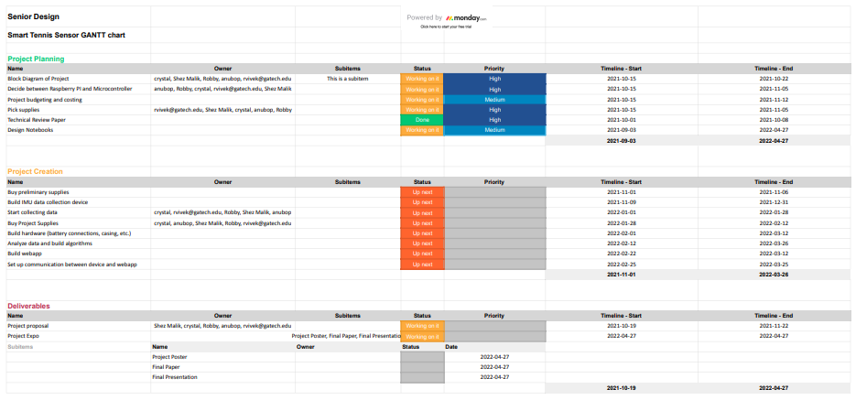



Appendix B - Team PERT Analysis Chart

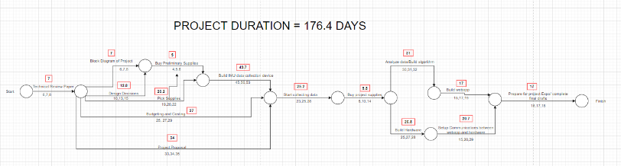

Appendix C - Team Cost Analysis

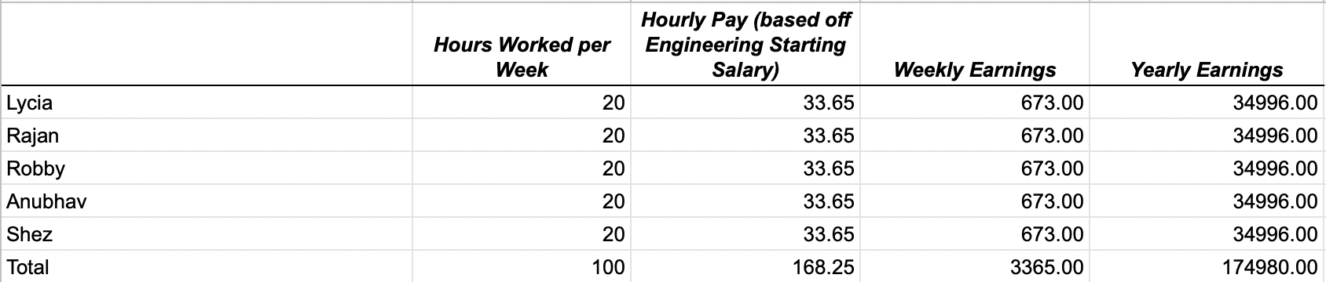

Table C.1. Labor Costs for Engineering Team.

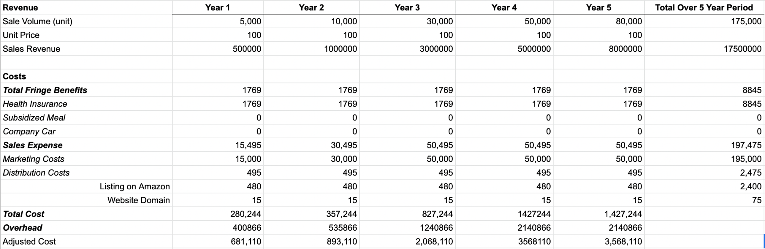

Table C.2. Yearly Company Costs Including Fringe Benefits and Sales Expenses.

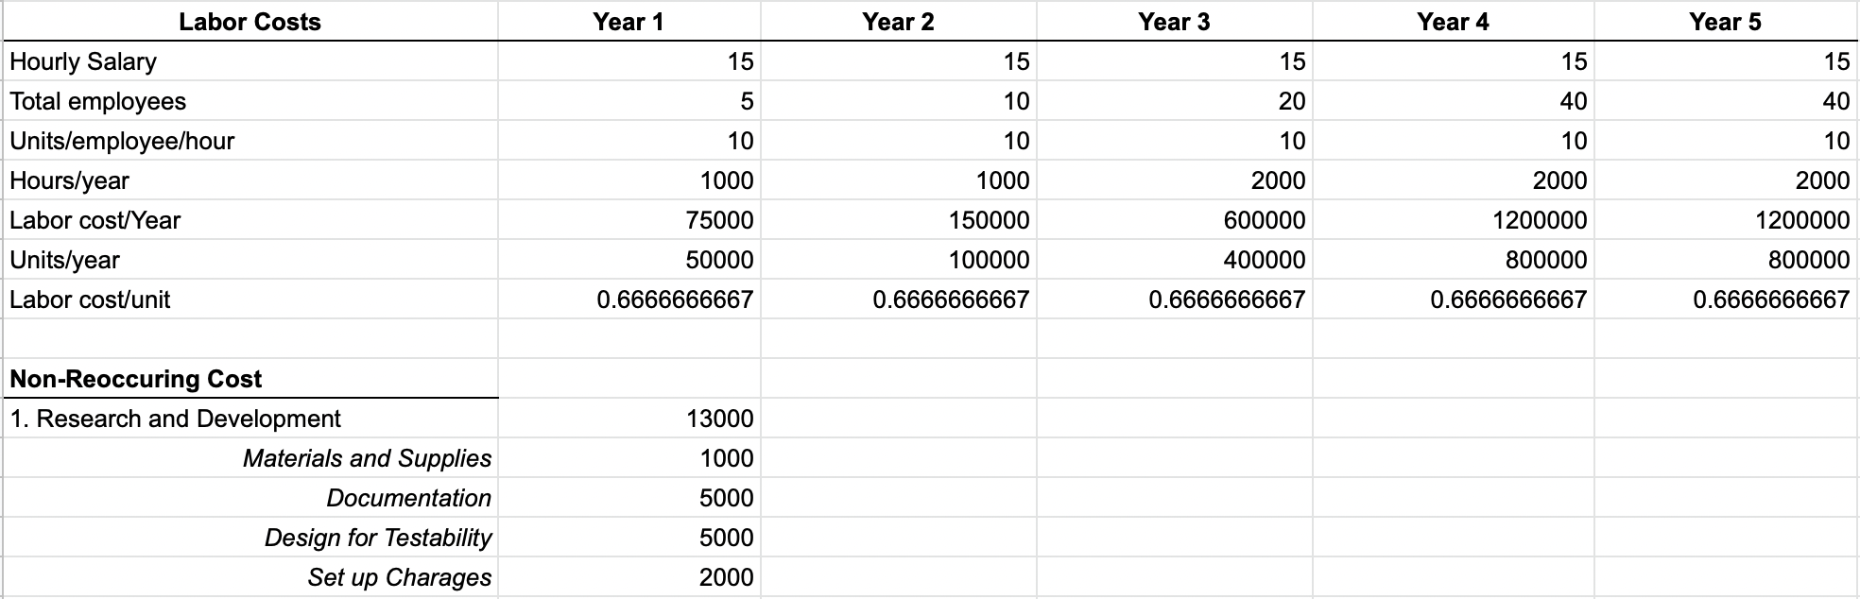

Table C.3. Yearly Company Labor Costs for Manufacturing.

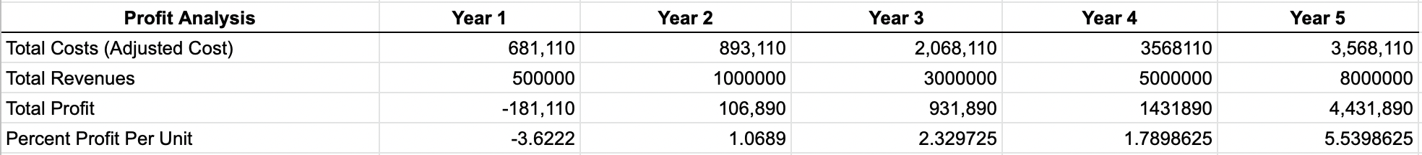

Table C.4. Yearly Profit Analysis.

Appendix D- QFD

